# CS 255 System Design Document Template

This template lays out all the different sections that you need to complete for Project Two. Each section has guidance to prompt your thinking. You will need to continually reference the interview transcript as you work to make sure that you are addressing your client’s needs. There is no required length for the final document. Instead the goal is to complete each section based on what your client’s needs are. Remove this note when you are finished, and replace all bracketed text with the relevant information.

## UML Diagrams

### UML Use Case Diagram

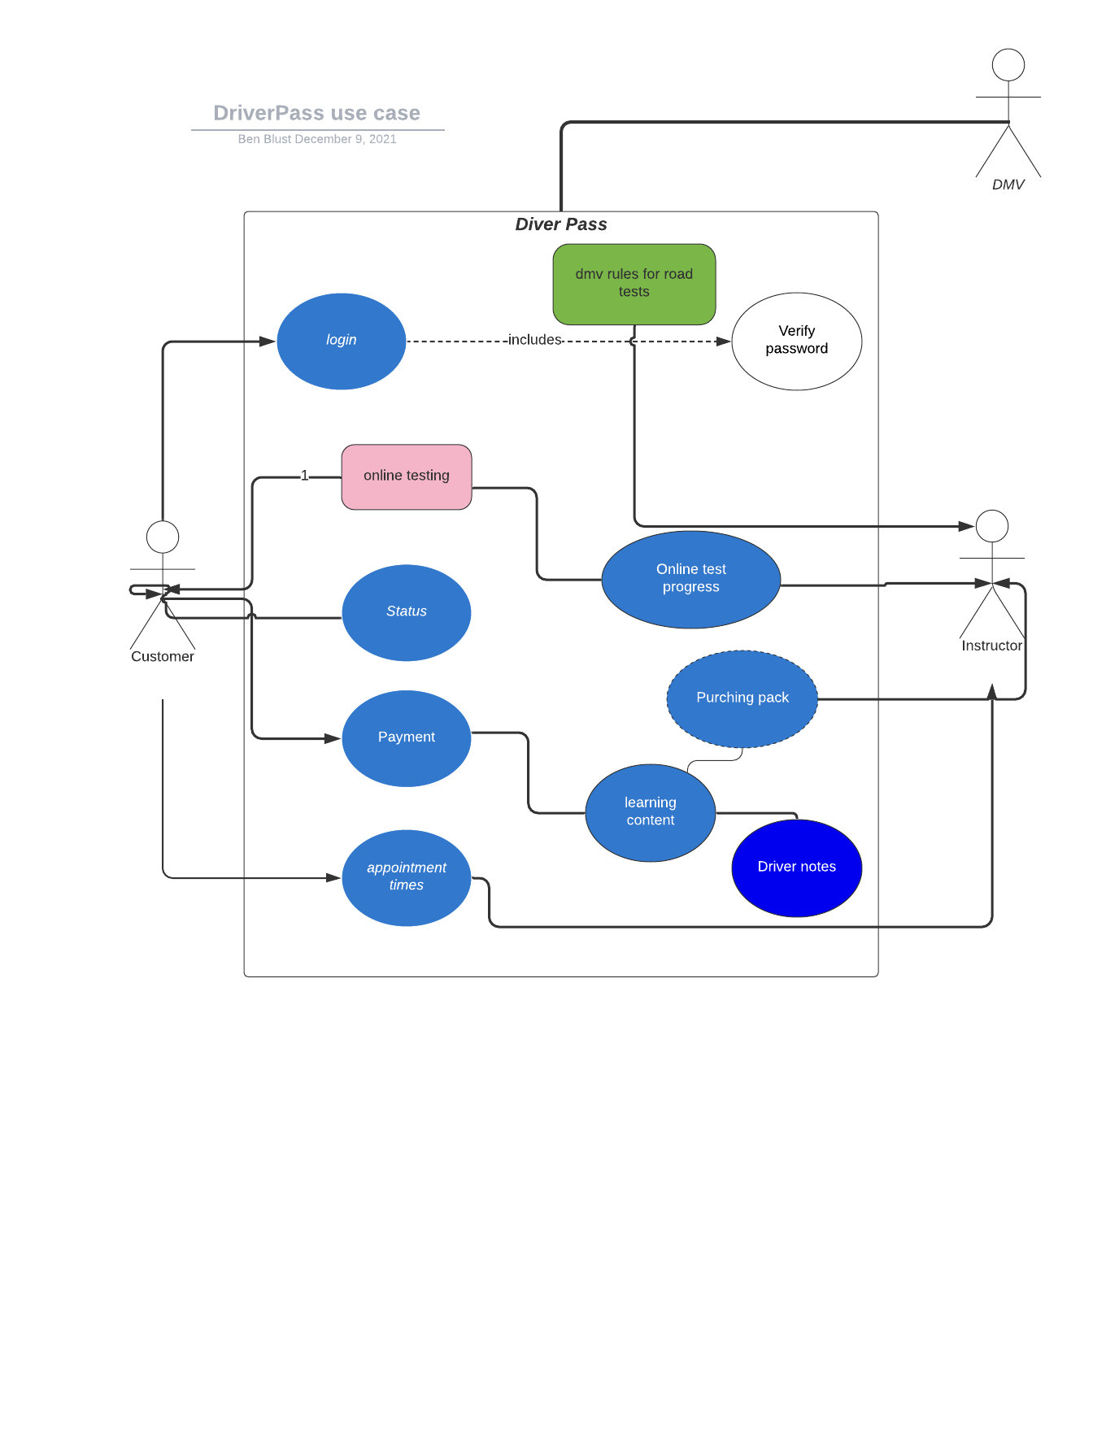

### UML Activity Diagrams

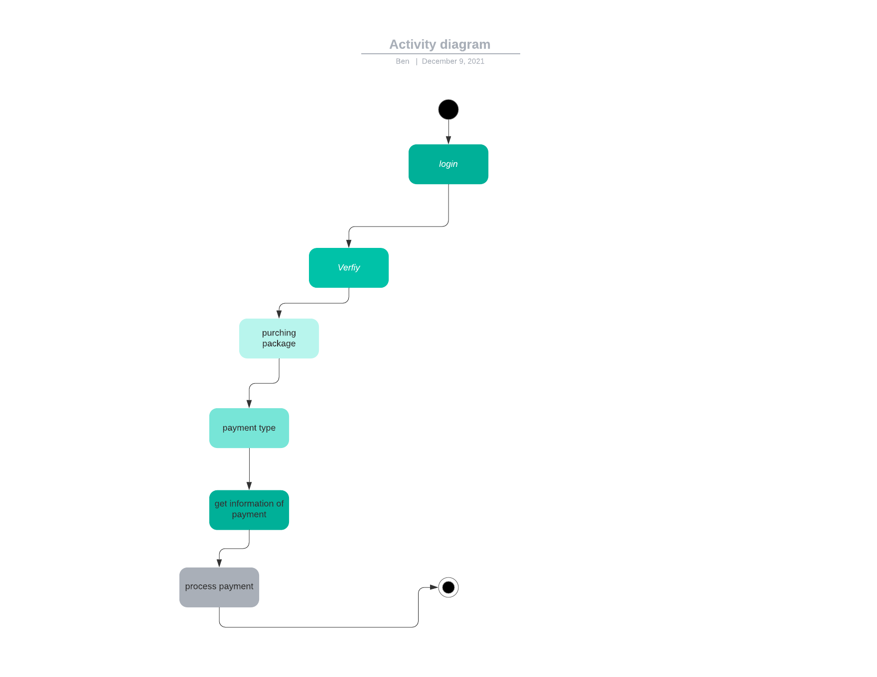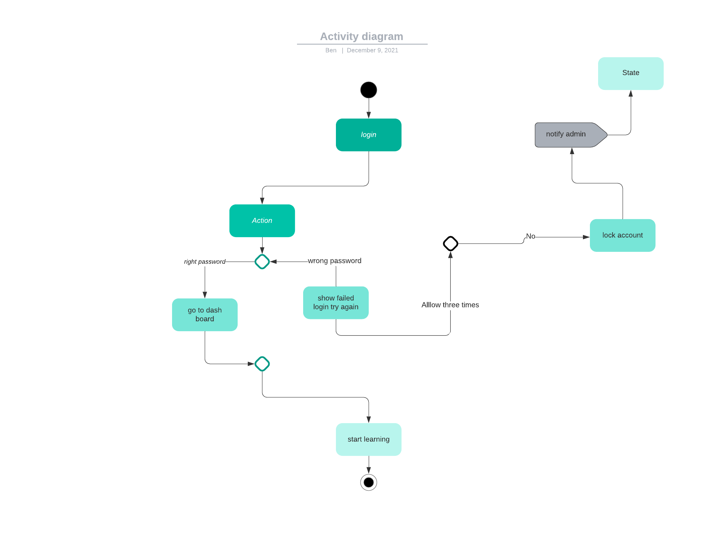

### UML Sequence Diagram

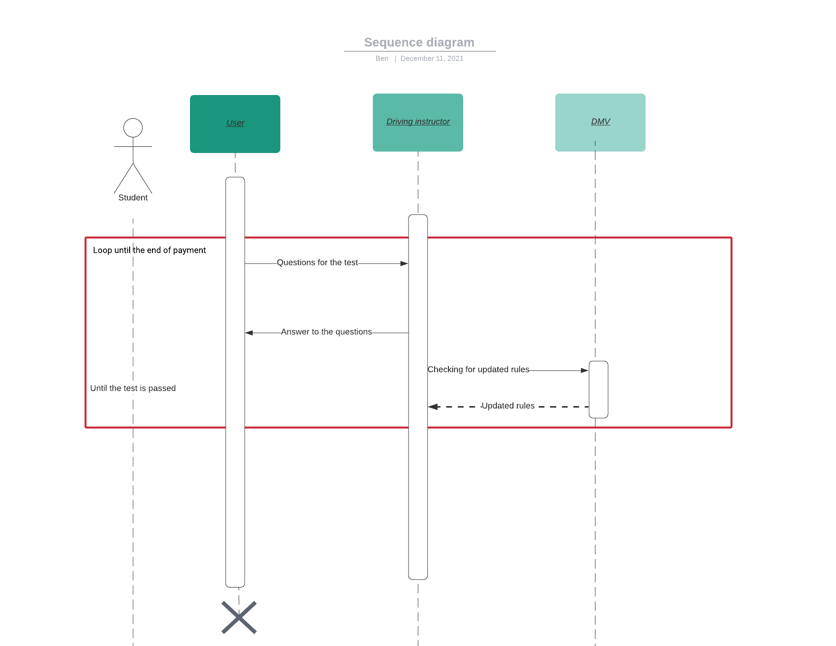

### UML Class Diagram

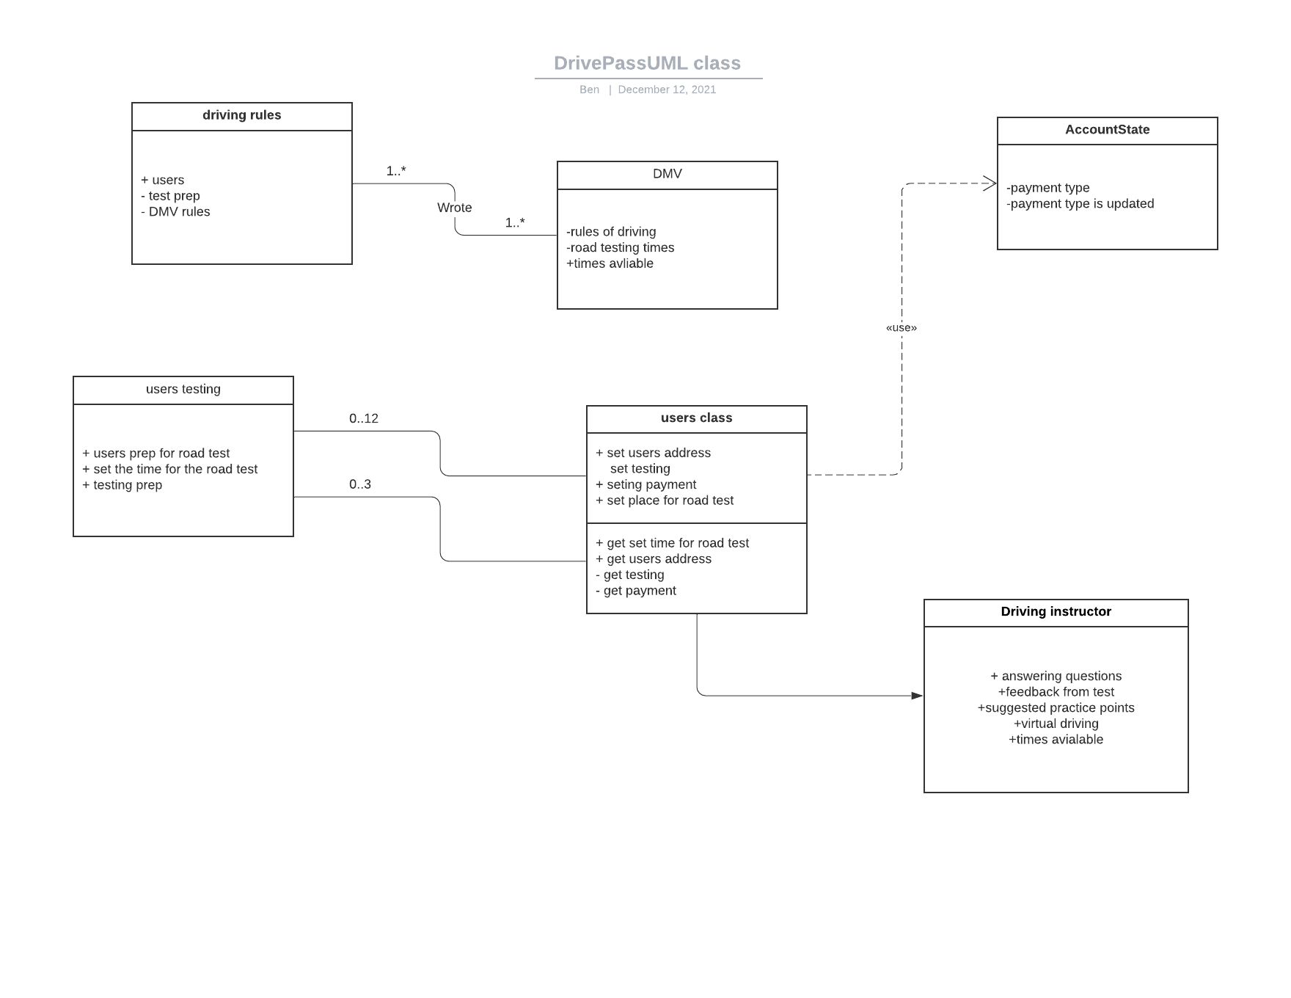

## Technical Requirements

I feel this is a pretty simple system with more or less basic requirements. I would recommend a cloud system, as it would be relatively inexpensive and a more convenient place to create and store a system with these requirements. From there we can set up with a few users as system admins and train them how to use the system and what they are responsible for. We could also bring some people on more knowledgeable about the system, such as the testers to help out, or someone with more experience in the particular responsibility, for example security, for some pointers and training. Running the mobile and desktop version in tandem is definitely the most difficult ask of this system, it is my opinion serious action towards that goal is better taken once the desktop version is up and running and the user base has grown. It is an easier requirement to revisit down the line, and with the added time and experience a lot of bugs would have been found and patched that would’ve been a lot harder had the mobile version also been int he equation. While starting to design this system there are some free software that can help us start the process. With this money saving option, and with our given time and budget we can put more focus on testing and implementing the features that are requested.